
BOSTON
INTERNATIONAL COLLEGE
END TERM EXAM
Level: Bachelor |  | Year : 2025
Programme: BCSIT Sem :II |  | Full Marks :100
Course: Data Structure and Algorithm |  | Time : 3 hrs.

Candidates are required to give their answers in their own words as far as practicable. The figures in the margin indicate full marks.
Group A
Very Short Answer Questions

Attempt all the questions. Give your answer in few lines. [10*2=20]
- Define Data structure. List its types.
- What is an algorithm and recursion?
- Write down four applications of stack.
- List two common operations performed on linked lists.
- How do AVL trees maintain balance?
- What is the key difference between internal and external sorting?
- What is a collision and rehashing in hashing?
- Define BFS and DFS.
- What is Big O and Omega notation.
- Define Divide and Conquer.

Section “B”
Descriptive Answer Questions
Attempt any five questions. [5×10=50]

- What is time and space complexity? Explain different types/classification of data structure with examples.
- Write an algorithm to convert and infix to postfix. Convert following infix to prefix expression ((A-(B+C))*D)^(E+F).
- Explain the drawback of Linear queue. Write a program in C to insert and delete data in a circular queue.
- Sort the following data using quick sort algorithm. 50, 40, 60, 35, 45, 55, 70, 30, 38, 42, 48, 53, 57, 65

- Explain Insertion sort with suitable example.
- Implement the simple hash function in C or Java code where h(x) = x%10.

- What is an AVL tree? Construct an AVL tree from the given data. 15,20,24,10,13,7,30,36,25 and show deletion of 7.

Section C
Attempt any two questions. [2×15=30]

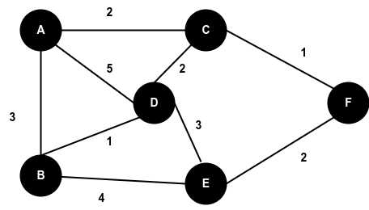
17..a. Define the terminologies:[5]
i. Undirected graph
ii. Double Linked List
iii. Rehashing
iv. Minimum Spanning Tree
v. Binary Search
b. Define MST. Find the shortest path from A to F using [10] Dijkstra algorithm.
- Define singly linked list. Write full code used to perform the following operation in a single linked list:
  - To delete a new node at the end of the list [5]
  - To insert a first node from the list. [5]
  - To display the data from the linked list. [5]
- Given input {31,53,13,59,54,9,79} and a hash function H(x)=x (mod 10)
  - Separate chaining [5]
  - Double Hashing [10]
    - Second hash function H(x)=7-(x) Mod 7

THE END

